
Opening Prayers of the
Morning Glory Divine Will Cenacle

Praying/ Reading/Studying

“The Kingdom of My Divine Will in the Midst of Creatures.
Book of Heaven.
The Call of the creature to
the Order,
the Place, and
the Purpose
for which he was Created by God”
Monday through Friday

and

The Rounds in the Divine Will
Saturday and Sunday

-all penned by Luisa Piccarreta,
Little Daughter of the Divine Will

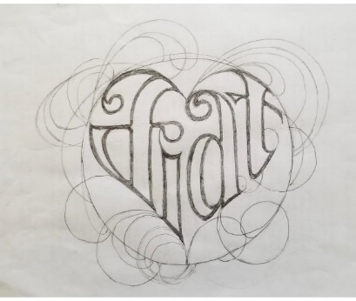

Morning Glory Cenacle - online since 2020

6:00 – 7:30 AM (Eastern Time)
5:00 – 6:30 AM (Central Time)

Link to Zoom meeting: https://us05web.zoom.us/j/89651501322?pwd=Ghb4y5J9xMwcMPba4X70XB5wBL0JN4.1

Spiritual Director:
Deacon John Thompson

To download needed documents:
- Prayer booklet
- Rounds booklet
- The Book of Heaven:
And to listen to recordings, go to
Ken Johnston’s web page, mgdwc.com
or https://www.notsaintsyet.org/cenacle-resources/

To join group text:
- Download the GroupMe app.
- Call or text Lynn Davis, 573-883-0439, to admit you.

For more information, contact Ken Johnston, BDV
E-mail: ken@inhissign.com
Phone: (215) 327-3236 - Cell (PREFERRED!)

Mary, Queen of the Divine Will, pray for us.
In the name of the Father, and of the Son, and of the Holy Spirit:

My Jesus, My Love
I enter into Your Divine Will, and I intend with these prayers,
to take, with Our Mother Mary,
Your Precious Blood
to every creature and creation, past, present, and future,
to repair and redo every thought, word, and act
not done in Your Will,
and give to God the Adoration and Thanksgiving
owed to Him as Creator. Amen
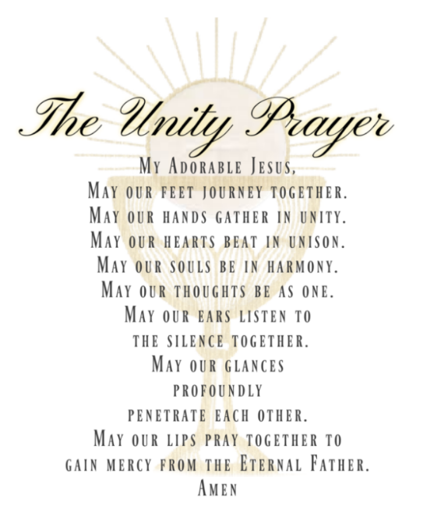

O Blessed Lady,
spread the effect of grace of thy flame of love over all humanity.
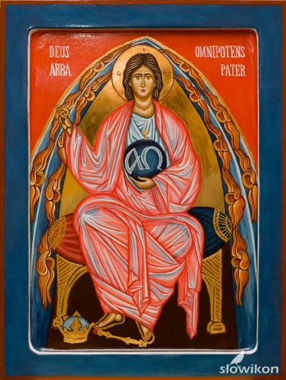
Fiat of the Eternal Father
My Beloved Father Thy Will be done on earth as it is in Heaven.
Be thou my Father.
Be always my Eternal Father.
Do not leave my soul.
Do not abandon me.
Do not leave me out of Your sight, my Father,
for I am Your child,
whom You have created to please You,
to adore You,
to honor You,
living my days as You have given me the license to live it.
(I offer up this Fiat through Mary to Jesus, to You, Eternal Father.)

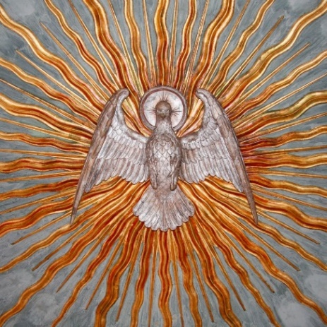

Come, Holy Spirit, Fill the hearts of Thy faithful
and enkindle in them the fire of Thy love.
Send forth Thy Spirit and they shall be created,
and Thou shalt renew the face of the earth.
Let us pray.
O God, Who did instruct the hearts of the faithful
by the light of the Holy Spirit,
Grant us in the same Spirit to be truly wise,
and ever to rejoice in His consolation. Through Christ, Our Lord. AMEN

The Prevenient Act / Rounds to Begin the Day

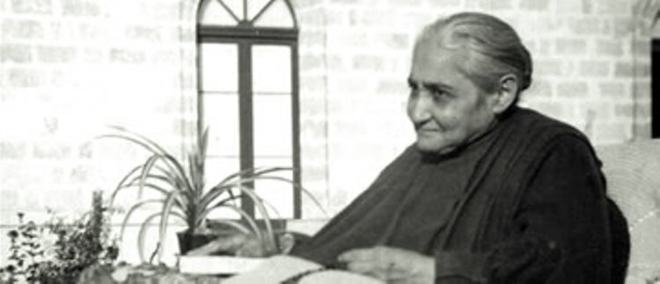
Most Holy Trinity, I thank and praise You for this new day, and setting my will in Yours, I affirm I want only to live and act in Your Will. Thus, making my Prevenient Act, “I set all my acts of the day in order in You (V 14: 5/27/1922)
Good morning, Blessed Mother, I love You; come, help me offer my first act of the day as an act of love in the Divine Will to God.
Good morning, my Jesus, I come to make my first act of the day, an act of love in your Divine Will. I immerse myself all in your Holy Will and embrace its immensity to multiply my act to the infinite in your Eternal Act.
First, I make my act diffuse in all the thoughts, in the glances, in the words, in the movements, in the steps, in the heartbeats, in each breath and in every act of every human being from Adam to the last creatures who will live upon the earth.
I offer this act to You, our Creator.
Then, since all things in Creation were made by God for the Love of the creature, I take this Love in the sun, the stars, the earth, the sea, the birds, the flowers and all the other things in Creation, and making it mine, I offer it as so many other acts of homage, of love, of blessings and of praise.
And going up in Paradise I make my rounds for all the Angels and for all the Saints; I unite myself to all the Heavenly Court, and for each and every one I give an act of love to You.
Next, I take all that which dear Luisa has done, who “has done good to everyone and has loved everyone and has operated in a universal manner for God and for everyone.” (Vol 19: 6/26/1926).
I take it as though mine, as well as all that has been and will be done by those who live in the Divine Will and work in this same universal manner, and offer it to You as a still more beautiful act of love.
Now I draw near to the Blessed Virgin, my dear Mother. She being ready to make a gift to me of all her merits; with the confidence of a little child, I take all she has done from the first instant of her Immaculate Conception to her last breath; and as if all were mine, I offer it to You, O God, as the most beautiful act.
And then I go to the Eternal Word made Man, and ask Him to make me partake in all his Acts: His Conception, His Birth, His escape into Egypt, His thirty years of Hidden Life, His years of Public Life, His Passion, His Death, His Resurrection and Ascension to Heaven. I make it all mine and offer it to You, O Sacrosanct Trinity.
And thus, as a poor miserable creature, do I offer You an act most complete and most holy, since I offer nothing of my own, but rather return to You all the glory from that which You have done. AMEN

Morning Offering in the Divine Will (Fr Iannuzzi)
O Immaculate Heart of Mary, Mother and Queen of the Divine Will, I entreat you, by the infinite merits of the Sacred Heart of Jesus, and by the graces God has granted to you since your Immaculate Conception, the grace of never going astray.
Most Sacred Heart of Jesus, I am a poor and unworthy sinner, and I beg of You the grace to allow our mother Mary and Luisa to form in me the divine acts You purchased for me and for everyone. These acts are the most precious of all, for they carry the Eternal Power of your Fiat and they await my “Yes, your Will be done”.
So, I implore you, Jesus, Mary and Luisa to accompany me as I now pray:
I am nothing and God is all, come Divine Will. Come Heavenly Father to beat in my heart and move in my Will; come beloved Son to flow in my Blood and think in my intellect; come Holy Spirit to breathe in my lungs and recall in my memory.
I fuse myself in the Divine Will and place my I love You, I adore You, and I bless You God, in the Fiats of Creation. With my I love You, my soul bilocates in the creations of the heavens and the earth: I love You in the stars, in the sun, in the moon and in the skies; I love You in the earth, in the waters and in every living creature my Father created out of love for me, so that I may return love for love.
I now enter into Jesus’ Most Holy Humanity that embraces all acts. I place my I adore You Jesus in your every breath, heartbeat, thought, word and step. I adore You in the sermons of your public life, in the miracles You performed, in the Sacraments You instituted and in the most intimate fibers of your Heart. I bless You Jesus in your every tear, blow, wound, thorn and in each drop of Blood that unleashed light for the life of every human. I bless You in all your prayers, reparations, offerings, and in each of the interior acts and sorrows You suffered up to your last breath on the Cross. I enclose your life and all your acts, Jesus, within my I love You I adore You and I bless You.
I now enter into the acts of my mother Mary and of Luisa. I place my I thank You in Mary and Luisa’s every thought, word and action. I thank You in the embraced joys and sorrows, in the work of Redemption and Sanctification.
Fused in your acts I make my I thank You and I bless You God flow in the relations of every creature to fill their acts with light and life: To fill the acts of Adam and Eve; of the patriarchs and prophets; of souls of the past, present and future; of the holy souls in purgatory; of the holy angels and saints.
I now make these acts my own, and I offer them to You, my tender and loving Father. May they increase the glory of your children, and may they glorify, satisfy and honor You on their behalf. Let us now begin our day with our divine acts fused together.
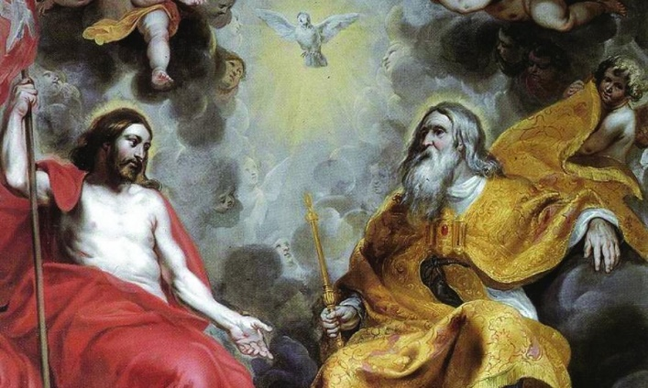
Thank You Most Holy Trinity for enabling me to enter into union with You by means of prayer. May your Kingdom come, and Your Will be done on earth as it is in heaven. Fiat!

Consecration to the Divine Will
Oh, adorable and Divine Will, behold me before the immensity of your Light, that your Eternal Goodness may open to me the doors and make me enter into It to form my life all in You, Divine Will.
Therefore, oh adorable Will, prostrate before your Light, I, the least of all creatures, put myself into the little group of the sons and daughters of your Supreme ‘Fiat’.
Prostrate in my nothingness, I invoke your Light and beg that it clothe me and eclipse all that does not pertain to You, Divine Will. It will be my Life, the center of my intelligence, the enrapturer of my heart and of my whole being. I do not want the human will to have life in this heart any longer. I will cast it away from me and thus form the new Eden of Peace, of Happiness and of Love. With it I shall be always happy. I shall have a singular strength and a holiness that sanctifies all things and conducts them to God.
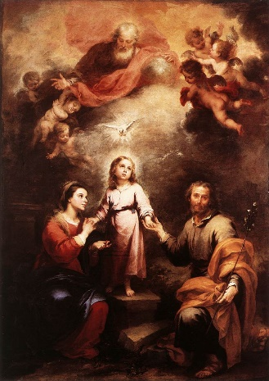
Here prostrate, I invoke the help of the Most Holy Trinity, that They permit me to live in the cloister of the Divine Will and thus return in me the first order of Creation, just as the creature was created.
Heavenly Mother, Sovereign Queen of the Divine ‘FIAT’, take my hand and introduce me into the Light of the Divine Will. You will be my guide, my most tender Mother, and You will teach me to live in and to maintain myself in the order and the bounds of the Divine Will.

Heavenly Mother, I consecrate my whole being to your Immaculate Heart. You will teach me the doctrine of the Divine Will and I will listen most attentively to your lessons. You will cover me with your mantle so that the infernal serpent, dare not penetrate into this sacred Eden to entice me and make me fall into the maze of the human will.
Heart of my greatest Good, Jesus. You will give me your flames that they may burn me, consume me, and feed me to form in me the Life of the Divine Will.
Saint Joseph, you will be my protector, the guardian of my heart, and will keep the keys of my will in your hands. You will keep my heart jealously and shall never give it to me again, that I may be sure of never leaving the Will of God.
My Guardian Angel, guard me; defend me; help me in everything so that my Eden may flourish and be the instrument that draws all men into the kingdom of the Divine Will. AMEN
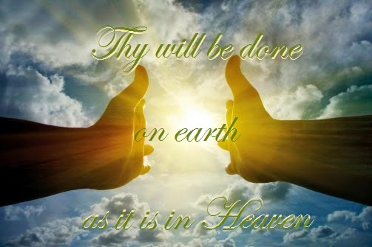
Prayer for Luisa’s Beatification
O Most Holy Trinity, Our Lord Jesus Christ taught us that, as we pray, we should ask that Our Father’s Name be always glorified, that His Will be done on earth and that His Kingdom should come to reign among us.
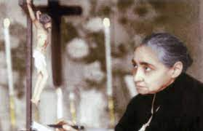
In our great desire to make known this Kingdom of Love, Justice and Peace we humbly ask that You glorify your Servant Luisa, the Little Daughter of the Divine Will, who, with her constant prayer and suffering deeply yearned for the salvation of souls and the coming of God’s Kingdom in the world.
Following her example, we pray You, Father, Son and Holy Spirit, to help us joyously embrace the crosses of this world so that we may also glorify your Name and enter into the Kingdom of Your Will. Amen
(from) St. Faustina’s Prayer for Priests
O MY Jesus, I beg You on behalf of the whole Church: Grant it love and the light of Your Spirit and give power to the words of priests so that hardened hearts might be brought to repentance and return to you, O Lord.
Lord, give us holy priests in The Divine Will; You Yourself maintain them in The Divine Will.
O Divine and Great High priest, May the power of your mercy accompany them everywhere and protect them from the devil’s snares which are continually being set for the souls of priests.
May the power of Your mercy, O Lord, shatter and bring to naught all that might tarnish the sanctity of priests, for You can do all things.
Prayer Before Each Lesson of the Divine Will Cenacle
May the Will of the Father, made known by the Son, through the Power of the Holy Spirit, reign in me through Mary, in every act I do this day and every act for the rest of my life.
May I enter into the Eternal, Divine Order of God, to place my absolute nothingness in the Heart of the Most Holy Trinity, to give to my Father the joy of fulfilling the purpose of my existence by doing all the acts of my life through the Immaculate Heart of my Mother, and in the Divine Will. And in this same manner, may I breathe, think, speak, pray, eat, live, act, work, walk and sleep.
May my soul be devoid of any longings, wants or desires, except for those of my beloved Divine Will, and may You, Lord, do with me whatever You want, long or desire! All I ask is that You bind me in Your Most Holy Will so intimately, that I may never swerve from carrying out what I know to be Your good pleasure, and that I remain so docile to the movements of Your Divine Will that You never perceive even a breath of resistance in my soul to Your desires for me!
Come Divine Will, with all the Angels and Saints, especially my Sweet Mother, to touch my forehead, and to imprint on it the Holy Spirit and infuse in me the Light, so I can understand the truths and goods that are in these writings and prayers!
Amen!

Jesus, consecrate me as a living host.
Lord, make me your living tabernacle. Fiat.

(Prayer to Redo the Acts Done by a Saint on Their Feast-day)
Today, I redo all the acts done by Saint ___________ and all the other saints and blessed and martyrs on this, their feast day. I redo all their acts in the Divine Will and offer them back to You, O God, our Creator.
May all these acts of love, of sacrifice, of suffering, of reparation, prayer, and praise elevate the glory of all the Saints in heaven. And may we, Lord, receive with greater intensity the gift of their continuous intercession in our pilgrimage here on earth. Amen. Fiat!

(-Prayer from V19: September 13, 1926)
‘Supreme Majesty, your little daughter comes before You, on your paternal knees, to ask You for your Fiat, your Kingdom, that It be known by all. I ask You for the triumph of your Will, that It may dominate and reign over all. I am not the only one who asks this of You, but with me are your works and your very Will. Therefore, in the name of all, I ask – I plead for your Fiat.’

Abba Father,
In the Name of Jesus, our Savior and King,
in the Unity and Love of the Holy Spirit, our Sanctifier,
under the Blue Mantle of our Divine Mother, Mary Most Holy,
with all the Holy Angels and Saints,
through the Intercession of the Servant of God, Luisa Piccarreta:

You Entrusted Your Kingdom of the Holy Divine Will
to Your little, newborn daughter, Luisa Piccarreta.
Luisa is the Object of Your Hope
because what you Placed in her
is the Destiny of the world.
You Deposited the Divine Will in Luisa, whose Mission it is
to give the Divine Will to the Pope,
so that Your priests will be the proclaimers of the Kingdom,
bringing all to Enter into this Universal Life.
We, the little children of the Holy Divine Will,
pray for our Holy Father
that the Supreme Fiat Invest and Form in him
the Divine Will as Primary Life.
As he embraces this Gift of Gifts,
the Sun of the Divine Will shall bring the Dawn of this Mystery
to all the world,
Forming One flock and One Shepherd - One Church.
We pray, Most Holy Trinity, take this humble prayer
and make it Your Command,
that all be Accomplished and Completed
in Your Most Holy Divine Will,
for Your Glory
and for the Triumph of the Immaculate Heart of Mary.
Fiat! Amen! So be it!

Then…
- (Friday? proceed to the next prayer ->)
- (weekday?) Next Round
- (Dec 16-24? -> Christmas Novena)
- (May? -> The Virgin Mary in the Kingdom of the Divine Will)
- (Saturday?) Rounds 1-12 (Sunday?) Rounds 13-24
- (weekday?) NEXT READINGS FROM THE BOOK OF HEAVEN

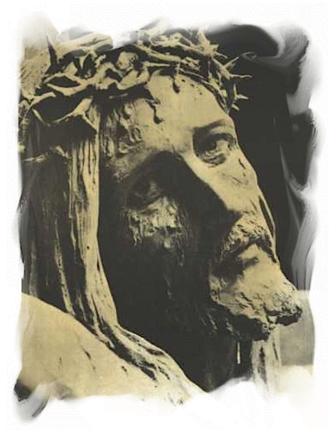
PRAYER TO DISARM DIVINE JUSTICE
–pray on Fridays

My good Jesus, I see that your enemies lift the heavy wood of the Cross and let It drop into the hole they had prepared; and You, my sweet Love, remain suspended between Heaven and earth. In this solemn moment, You turn to the Father, and with weak and feeble voice, You say to Him: “Holy Father, here I am, loaded down with all the sins of the world. There is not one sin which does not pour upon Me; therefore, no longer unload the scourges of your Divine Justice upon man, but upon Me, your Son. O Father, allow Me to bind all souls to this Cross, and to plead forgiveness for them with the voices of my Blood and of my wounds. O Father, do You not see how I have reduced Myself?
By this Cross, by virtue of these pains, concede true conversion, peace, forgiveness and sanctity to all. Arrest your fury against poor humanity, against my children. They are blind, and know not what they are doing. Look well at Me, how I have reduced Myself because of them; if You are not moved to compassion for them, may You at least be softened by this Face of mine, dirtied with spit, covered with Blood, bruised and swollen by the so many slaps and blows received. Have pity, my Father! I was the most beautiful of all, and now I am all disfigured, to the point that I no longer recognize Myself. I have become the abject of all; and so, at any cost, I want to save the poor creature!”
My Jesus, how is it possible that You love us so much? Your love crushes my poor heart. Oh, I would want to go into the midst of all creatures to show this Face of Yours, so disfigured because of them, to move them to compassion for their own souls and for your love; and with the light which emanates from your Face, and with the enrapturing power of your love, make them understand who You are, and who they are, who dare to offend You, so that they may prostrate themselves before You, to adore You and glorify You.
My Jesus, adorable Crucified, the creature continues to irritate Divine Justice, and with her tongue, she makes resound the echo of horrible blasphemies, voices of curses and maledictions, and evil discourses. Ah, all these voices deafen the earth, and penetrating even into the Heavens, while deafening the divine hearing, they curse and ask for revenge and justice against her! Oh, how Divine Justice feels pressed to hurl Its scourges! Oh, how the many horrendous blasphemies ignite Its fury against the creature!
***
But You, O my Jesus, loving us with highest love, face these deadly voices with your omnipotent and creative voice, and cry out for mercy, graces and love for the creature. In order to appease the indignation of the Father, all love, You say to Him:
“My Father, look at Me once again, do not listen to the voices of the creatures, but to mine; I am the One who satisfies for all. Therefore, I pray You to look at the creature, and to look at her in Me; if You look at her outside of Me, what will happen to her? She is weak, ignorant, capable only of doing evil, and full of miseries. Have pity – pity on the poor creature. I answer for her with my tongue embittered by bile, parched by thirst, dried and burned by love.”
My embittered Jesus, my voice in Yours wants to face all these offenses, all the blasphemies, in order to change all human voices into voices of blessings and praises.
My Crucified Jesus, at so much love and pain of yours, the creature does not yet surrender; on the contrary, she despises You and adds sins to sins, committing enormous sacrileges, murders, suicides, duels, frauds, deceits, cruelties and betrayals. Ah, all these evil works weigh on the arms of your Celestial Father; so much so, that unable to sustain their weight, He is about to lower them and pour fury and destruction upon the earth. And You, O my Jesus, to snatch the creature from the divine fury, fearing to see her destroyed - You stretch out your arms to the Father, You disarm Him, and prevent Divine Justice from taking Its course. And to move Him to compassion for miserable Humanity and to soften Him, You say to Him with the most persuasive voice:
“My Father, look at these hands, ripped open, and the nails that pierce them, which nail them together with all these evil works. Ah, in these hands I feel all the spasms that these evil works give to Me. Are You not content, O my Father, with my pains? Am I perhaps not capable of satisfying You? Yes, these dislocated arms of mine will always be chains to hold the poor creatures tightly, so that they may not escape from Me, except for those who wanted to struggle free by sheer force. These arms of mine will be loving chains that will bind You, my Father, to prevent You from destroying the poor creature. Even more, I will draw You closer and closer to her, that You may pour your graces and mercies upon her!”
My Jesus, your love is a sweet enchantment for me, and pushes me to do what You do. So, together with You, at the cost of any pain, I want to prevent Divine Justice from taking Its course against poor Humanity. With the Blood that pours out of your hands I want to extinguish the fire of sin that ignites It, and to calm Its fury.
***
Allow me to place in your arms, the sufferings and the torments of all men, and the many hearts, grieving and oppressed. Allow me to go among all creatures and press them all into your arms, so that all of them may return to your Heart. By the power of your creative hands, allow me to stop the current of so many evil works, and to hold everyone back from doing evil.
My lovable crucified Jesus, the creature is not yet content in offending You. She wants to drink, to the bottom, all the filth of sin, and she runs almost wildly along the path of evil. She falls from sin to sin, disobeys all of your Laws, and denying You, rebels against You, and almost out of spite, she wants to go to hell. Oh, how indignant becomes the Supreme Majesty! And You, O my Jesus, triumphing of everything, even over the obstinacyof creatures, in order to appease the Divine Father, show Him all of your Most Holy Humanity, lacerated, dislocated, tortured in a horrible way. You show your most holy feet, pierced, twisted by the atrocity of the spasms, and I hear your voice, more moving than ever, as though in act of breathing its last, wanting to conquer the creature by force of love and pain, and to triumph over the Paternal Heart:
“My Father, look at Me, from head to foot; there is not one part of Me which is left whole. I do not know where else to let them open more wounds and to procure more sufferings. If You do not placate Yourself at this sight of love and suffering, who will ever be able to appease You? O creatures, if you do not surrender to so much love, what hope remains for you to convert? These wounds and Blood of Mine will be voices that constantly call from Heaven to earth, graces of repentance, forgiveness and compassion for you!”
My Jesus, Crucified Lover, I see that You can take no more. The terrible tension that You suffer on the Cross, the continual creaking of your bones that dislocate more and more at every tiny movement, your flesh that rips more and more, the ardent thirst that consumes You, the interior pains that suffocate You with bitterness, pain and love - and, in the face of so many martyrdoms, the human ingratitude that insults You and penetrates, like a mighty wave, into your pierced Heart, oppress You so much that your Most Holy Humanity, unable to bear the weight of so many martyrdoms, is about to end, and raving with love and suffering, cries out for help and pity! Crucified Jesus, is it possible that You, who rule everything and give life to all, ask for help? Ah, how I wish to penetrate into each drop of your most precious Blood, and to pour my own in order to soothe each one of your wounds, to lessen and render less painful the pricks of each thorn, and into every interior pain of your Heart to relieve the intensity of your bitternesses.
***
I wish I could give You life for life. If it were possible, I would want to unnail You from the Cross and put myself in your place; but I see that I am nothing and can do nothing - I am too insignificant. Therefore, give me Yourself; I will take life in You, and in You, I will give You Yourself. In this way You will satisfy my yearnings.
Tortured Jesus, I see that your Most Holy Humanity is ending, not because of You, but to fulfill our Redemption in everything. You need divine aid, and so You throw Yourself into the Paternal arms and ask for help and assistance.
Oh, how moved is the Divine Father in looking at the horrible torture of your Most Holy Humanity, the terrible crafting that sin has made upon your most holy members! And to satisfy your yearnings of love, He holds You to His Paternal Heart, and gives You the necessary helps to accomplish our Redemption; and as He holds You tightly, You feel again in your Heart, more intensely, the blows of the nails, the lashes of the scourging, the tearing of the wounds, the pricking of the thorns. Oh, how the Father is struck! How indignant He becomes in seeing that all these pains are given to You, up into your inmost Heart, even by souls consecrated to You! And in His sorrow, He says to You:
“Is it possible, my Son, that not even the part chosen by You is wholly with You? On the contrary, it seems that these souls ask for refuge and a hiding place in your Heart in order to embitter You and give You a more painful death. And even more, all these pains they give to You, are hidden and covered by hypocrisy. Ah, Son, I can no longer contain my indignation at the ingratitude of these souls, who grieve Me more than all the other creatures together!”
But You, O my Jesus, triumphing of everything, defend also these souls, and with the immense love of your Heart, form a shield to the waves of bitternesses and piercings that these souls give You. And to appease the Father, You say to Him:
“My Father, look at this Heart of Mine. May all these pains satisfy You; and the more bitter they are, the more powerful may they be over your Heart of Father, to plead graces, light and forgiveness for them. My Father, do not reject them; they will be my defenders who will continue my life upon earth.”
My Life, Crucified Jesus, I see You still agonizing on the Cross, because your love is not yet satisfied in order to give completion to all. I too, yes, agonize together with You. And all of you, Angels and Saints – come to Mount Calvary, to admire the excesses, and the follies of the love of a God!
***
Let us kiss His bleeding wounds; let us adore them; let us sustain those lacerated limbs; let us thank Jesus for the accomplished Redemption. Let us turn our gaze to the pierced Mother, who feels pains and deaths in Her Immaculate Heart, for as many pains as She sees in Her Son God. Her own clothes are soaked with His Blood; Mount Calvary is all covered with It. So, all together, let us take this Blood, let us ask the sorrowful Mother to unite Herself to us; let us divide ourselves throughout the whole world, and let us go to the help of all.
Let us help those who are in danger, that they may not perish; those who have fallen, that they may stand up again; those who are about to fall, that they may not fall. Let us give this Blood to the many poor blind, that the light of truth may shine in them. In a special way, let us go into the midst of the poor soldiers, to be their vigilant sentries, and if they are about to be struck by the lead of the enemy, let us receive them into our arms, to comfort them. And if they are abandoned by all, if they are desperate with their sad destiny, let us give them this Blood that they may be resigned, and the atrocity of the pain lessened. And if we see that there are souls who are about to fall into hell, let us give them this Divine Blood, which contains the price of Redemption - let us snatch them from Satan! And while I hold Jesus tightly to my heart in order to defend Him and shelter Him from everything, I will hold everyone to this Heart, so that all may obtain effective grace of conversion, strength and salvation.
Meanwhile, O Jesus, I see that your Blood flows in torrents from your hands and from your feet. The Angels, weeping, surrounding You like a crown, admire the portents of your immense love. I see your sweet Mama, pierced by pain, at the foot of the Cross; your dear Magdalene, beloved John – all taken by ecstasy of awe, love and pain! O Jesus, I unite myself to You and I cling to your Cross; I take all the drops of your Blood and I pour them into my heart. When I see your Justice irritated against sinners, I will show You this Blood in order to appease You. When I want the conversion of souls obstinate in sin, I will show You this Blood, and by virtue of It You will not reject my prayer, because I hold Its pledge in my hands.
And now, my Crucified Good, in the name of all generations, past, present and future, together with your Mama and with all the Angels, I prostrate myself before You and say: “We adore You, O Christ, and we bless You, because by your Holy Cross You have redeemed the world.”
In the Name of the Father, and of the Son, and of the Holy Spirit, Amen. Fiat!
Come Divine Will!

